# Experiment3

**Student Name:** Arpit Rana **UID:** 22BCS10776 **Branch:** BE-CSE **Section/Group:**22BCS_NTPP_603’A’ **Semester:** 6th **Date of Performance:** 21-01-25

**SubjectName:**APLab-2 **SubjectCode:**22CSP-351

## Aim:[MergeTwoSortedLists](https://leetcode.com/problems/merge-two-sorted-lists/)

1. **Objective:**

Youaregiventheheadsoftwosortedlinkedlistslist1andlist2.

Mergethetwolistsintoonesortedlist.Thelistshouldbemadeby splicing together the nodes of the first two lists.

Returntheheadofthemergedlinkedlist. Example 1:

Input:list1=[1,2,4],list2=[1,3,4]

Output:[1,1,2,3,4,4]

## Implementation/Code:

ListNode*mergeTwoLists(ListNode*list1,ListNode*list2){ ListNode dummy(0);

ListNode*tail=&dummy;

while(list1!=NULL&&list2!=NULL){ if (list1->val < list2->val) {

tail->next = list1; list1=list1->next;

}else {

tail->next = list2; list2=list2->next;

}

tail=tail->next;

}

if(list1!=NULL){ tail->next=list1;

}else{

tail->next=list2;

}

returndummy.next;

}

## Output

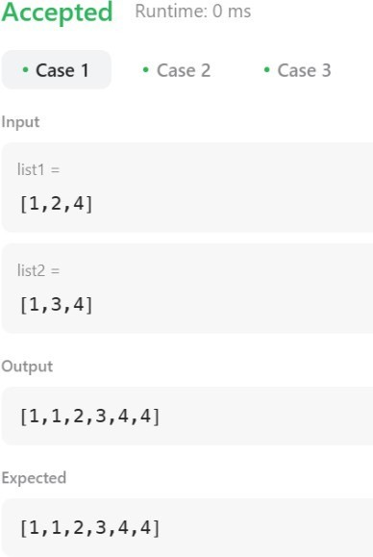

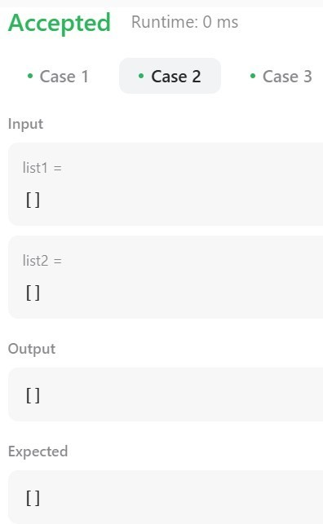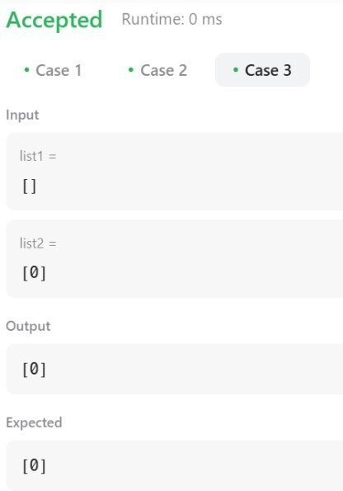

1. **LearningOutcome:**
   1. WeLearnAbouttheuseofDummyNode.
   2. WeLearnAbouttheuseofll.
   3. WeLearnAbouttheuseofindexing.
   4. WelearnAbouttheorderedNextNode.
   5. WeLearnAbouttheCallingForthefunction.

# Question2.

1. **Aim:**[**RemoveDuplicatesfromSortedList**](https://leetcode.com/problems/remove-duplicates-from-sorted-list/)

## Objective:

Giventheheadofasortedlinkedlist,*deleteallduplicatessuchthateach element appears only once*. Return *the linked list* ***sorted*** *as well*.

Example1:

**Input:**head =[1,1,2]

**Output:**[1,2]

## Implementation/Code:

ListNode*deleteDuplicates(ListNode*head){ if (head == NULL) return NULL;

ListNode*current=head;

while(current->next!=NULL){

if(current->val==current->next->val){

ListNode* temp = current->next; current->next = current->next->next; delete temp;

}else {

current=current->next;

}

}

returnhead;

}

## Output

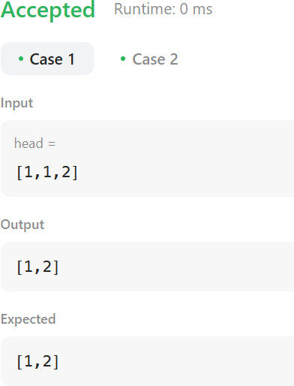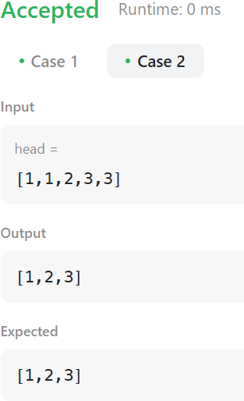

1. **LearningOutcome:**
2. WeLearnAbouttheuseofRunningLL.
3. WeLearnAbouttheuseoftempll.
4. WeLearnAbouttheuseofDeletefunction.
5. WelearnAboutthemovefromonenode.
6. WeLearnAbouttheuseofwhileloop.